# **Part 1**

1. For salary, education, and prestige

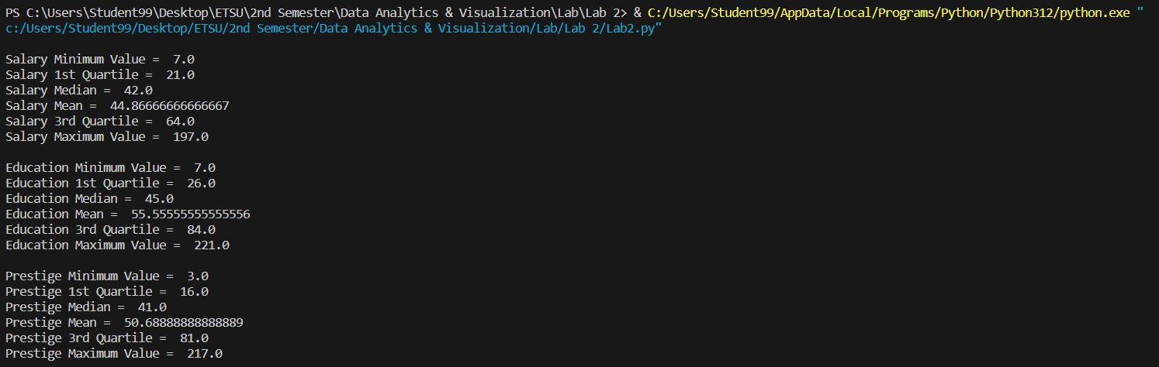

1. Histogram for prestige

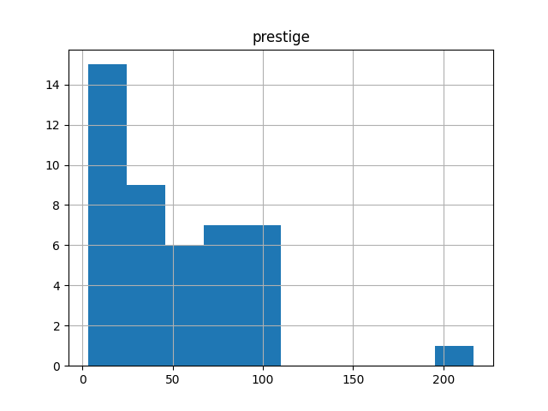

1. Histogram for education

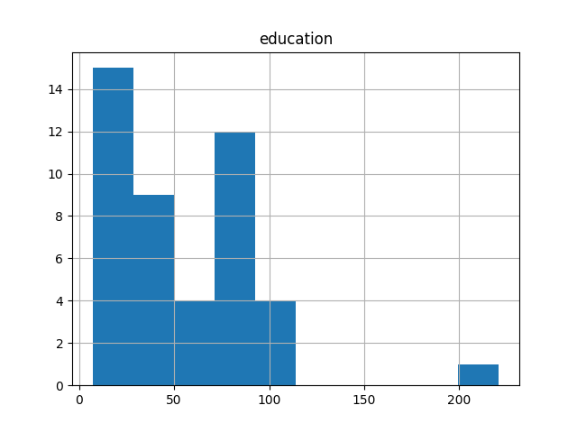

1. Scatter plot for salary and education

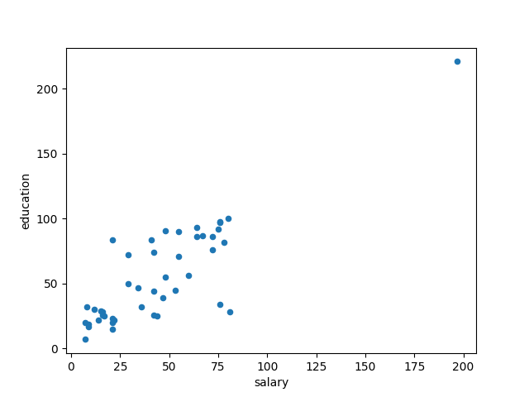

1. Scatter plot for education and prestige

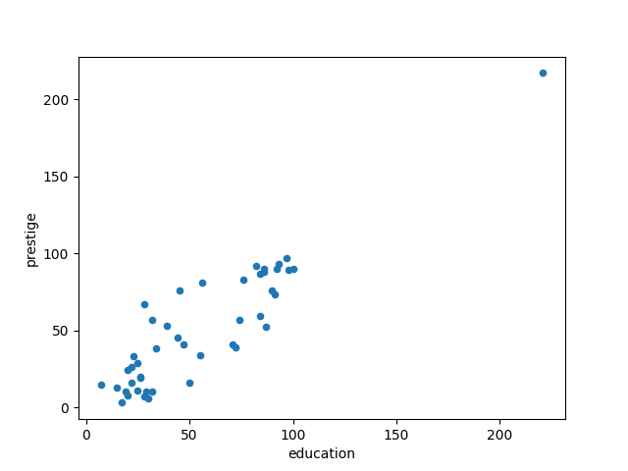

1. Variance and standard deviation for salary



1. Explain what does variance measure.

* Variance measures the exaggerated dispersion of data. It measures the quantity by which the data set is deviated from its mean value. It indicates how far the data values are away from their mean value.

1. What does a high variance value mean?

* A high variance value means that the data in a data set are highly different. It also indicates that the data are hugely spread out from their mean.

1. As a data analysts, if you calculate the salary variance and it is 0 (zero). What does that mean? Is it good or bad?

* If the variance of the salary is 0 (zero), it means that all the people listed in the list have the same amount of salary value, which is also the mean value of the salary.
* In the context of data analysis, the variance being 0 (zero) does not provide any meaningful information for further analyzing the data as the value for all the cases is the same. Therefore, it is not good to have a variance equal to 0 (zero).

# **Part 2**

1. d(Witcher 3, Mortal Kombat 11) = $\frac{Number of all attributes \left(p\right)-Number of matching attributes (m)}{Number of all attributes \left(p\right)}$

= (3-1)/3

= 2/3

= 0.67

1. d(Super Mario Bros., Super Sonic) = $\frac{Number of all attributes \left(p\right)-Number of matching attributes (m)}{Number of all attributes \left(p\right)}$

= (3-2)/2

= 1/2

= 0.33